ELEVENTH SCHEDULE
(Paragraph 62)
RULES OF THE AIR AND AIR TRAFFIC CONTROL
PART I - INTERPRETATION
1. In these Rules, unless the context otherwise requires:
Aerodrome reference point means the notified geographical location of an aerodrome.
Air traffic control clearance means authorisation by an air traffic control unit for an aircraft to proceed under conditions specified by that unit.
Anti-collision light means a flashing red or flashing white light showing in all directions for the purpose of enabling the aircraft to be more readily detected by the pilots of distant aircraft.
Apron means the part of an aerodrome provided for the stationing of aircraft for the embarkation and disembarkation of passengers, the loading and unloading of cargo and for parking.
Cloud ceiling in relation to an aerodrome means the distance measured vertically from the notified elevation of that aerodrome to the lowest part of any cloud visible from the aerodrome which is sufficient to obscure more than one-half of the sky so visible.
Ground visibility means the horizontal visibility at ground level.
IFR flight means a flight conducted in accordance with the Instrument Flight Rules in Part VI of these Rules.
Manoeuvring area means that part of an aerodrome provided for the take-off and landing of aircraft and for the movement of aircraft on the surface, excluding the apron and any part of the aerodrome provided for the maintenance of aircraft.
Runway means an area, whether or not paved, which is provided for the take-off or landing run of aircraft.
VFR flight means a flight conducted in accordance with the Visual Flight Rules in Part V of these Rules.
PART II - GENERAL
Application of rules to aircraft
2. These Rules, insofar as they are applicable in relation to aircraft, shall, subject to rule 30, apply in relation to:
(a) all aircraft whilst in Macao; and
(b) all Macao aircraft, wherever they may be.
Misuse of signals and markings
3. (1) A signal marking to which a meaning is given by these Rules, or which is required by these Rules to be used in circumstances or for a purpose therein specified, shall not be used except with that meaning, or for that purpose.
(2) A person in an aircraft or on an aerodrome or at any place at which an aircraft taking off or landing shall not make any signal which may be confused with a signal specified in these Rules, and, except with lawful authority, shall not make any signal which he knows or ought reasonably to know to be a signal in use for signalling to or from an aircraft of the Armed Forces.
Reporting hazardous conditions
4. The commander of an aircraft shall, on meeting with hazardous conditions in the course of a flight, or as soon as possible thereafter, send to the appropriate air traffic control unit by the quickest means available information containing such particulars of the hazardous conditions as may be pertinent to the safety of other aircraft.
Low flying
5. (1) Subject to paragraphs (2) and (3):
(a) an aircraft, other than a helicopter, shall not fly over any congested area of a city, town or settlement below:
(i) such height as would enable the aircraft to alight clear of the area and without danger to persons or property on the surface, in the event of failure of a power unit; or
(ii) a height of 1,500 feet above the highest fixed object within 2,000 feet of the aircraft, whichever is the higher;
(b) a helicopter shall not fly below such height as would enable it to alight without danger to persons or property on the surface, in the event of failure of a power unit;
(c) except with the permission in writing of the Civil Aviation Authority and in accordance with any conditions therein specified a helicopter shall not fly:
(i) over a congested area of a city, town or settlement, below a height of 1,500 feet above the highest fixed object within 2,000 feet of the helicopter; or
(ii) over any area notified for the purpose of this sub-paragraph, below such height as would enable it to alight clear
(d) an aircraft shall not fly:
(i) over, or within 3,000 feet of any assembly in the open air of more than 1,000 persons assembled for the purpose of witnessing or participating in any organised event, except with the permission in writing of the Civil Aviation Authority and in accordance with any conditions therein specified and with the consent in writing of the organisers of the event; or
(ii) below such height as would enable it to alight clear of the assembly in the event of failure of a power unit:
Provided that where a person is charged with an offence under the Regulation by reason of a contravention of this sub-paragraph, it shall be a good defence to prove that the flight of the aircraft over or within 3,000 feet of the assembly was made at a reasonable height and for a reason not connected with the assembly or with the event which was the occasion for the assembly;
(e) an aircraft shall not fly closer than 500 feet to any person, vessel, vehicle or structure;
(2) (a) sub-paragraph (1) (d) and (e) shall not apply to an aircraft which is being used for police purposes.
(b) sub-paragraph (1) (d) and (e) shall not apply to the flight of an aircraft over or within 3,000 feet of an assembly of persons gathered for the purpose of witnessing an event which consists wholly or principally of an aircraft race or contest or an exhibition of flying, if the aircraft is taking part in such a race, contest or exhibition or is engaged in a flight arranged by, or made with the consent in writing of, the organisers of the event, and the races, contest, exhibition or flight are approved by the Civil Aviation Authority.
(c) sub-paragraph (1) (e) shall not apply to:
(i) any aircraft while it is landing or taking off in accordance with normal aviation practice; and
(ii) any glider while it is hill-soaring.
(d) The alternatives in sub-paragraphs (1) (a) (ii) and (1) (c) (i) shall not apply to an aircraft flying:
(i) on a route notified for the purposes of this rule; or
(ii) on a special VFR flight as defined in rule 23 in accordance with instructions given for the purposes of that rule by the appropriate air traffic control unit.
(3) Nothing in this rule shall prohibit any aircraft from:
(a) taking off, landing or practising approaches to landing; or
(b) flying for the purpose of checking navigational aids or procedures in accordance with normal aviation practice at a Government or licensed aerodrome in Macao or at any aerodrome in any Contracting State; or
(c) flying in such a manner as may be necessary for the purpose of saving life:
Provided that in the case of practising approaches to landing as aforesaid such practising is confined to the airspace customarily used by aircraft when landing or taking off in accordance with normal aviation practice at the aerodrome concerned.
(4) Nothing in this rule shall apply to any captive balloon or kite.
Simulated instrument flight
6. An aircraft shall not be flown in simulated instrument flight conditions unless:
(a) the aircraft is fitted with dual controls which are functioning properly;
(b) an additional pilot (referred to in this rule as a safety pilot) is carried in a second control seat of the aircraft for the purpose of rendering such assistance as may be necessary to the pilot flying the aircraft; and
(c) if the safety pilot's field of vision is not adequate both forward and to each side of the aircraft, a third person, being an observer approved by the Civil Aviation Authority, shall occupy a position in the aircraft from which his field of vision makes good the deficiencies of the field of vision of the safety pilot, and from which he can readily communicate with the safety pilot.
For the purposes of this rule the expression "simulated instrument flight" means a flight during which mechanical or optical devices are used in order to reduce the field of vision or the range of visibility from the cockpit of the aircraft.
Practice instrument approaches
7. Within Macao, an aircraft shall not carry out instrument approach practice when flying in Visual Meteorological Conditions unless:
(a) the appropriate air traffic control unit has previously been informed that the flight is to be made for the purpose of instrument approach practice; and
(b) if the flight is not being carried out in simulated instrument flight conditions, an observer approved by the Civil Aviation Authority is carried in such a position in the aircraft that he has an adequate field of vision and can readily communicate with the pilot flying the aircraft.
PART III - LIGHTS AND OTHER SIGNALS TO BE SHOWN BY AIRCRAFT
General
8. (1) For the purpose of this Part the horizontal plane of a light shown by an aircraft means the plane which would be the horizontal plane passing through the source of that light, if the aircraft were in level flight.
(2) Where by reason of the physical construction of an aircraft it is necessary to fit more than one lamp in order to show a light required by this part of these Rules, the lamps shall be so fitted and constructed that, so far as is reasonably practicable, not more than one such lamp is visible from any one point outside the aircraft.
(3) Where in these Rules a light is required to show through specified angles in the horizontal plane, the lamps giving such light shall be so constructed and fitted that the light is visible from any point in any vertical plane within those angles throughout angles of 90° above and below the horizontal plane, but, so far as is reasonably practicable, through no greater angle, either in the horizontal plane or the vertical plane.
(4) Where in these Rules a light is required to show in all directions the lamps giving such light shall be so constructed and fitted that, so far as is reasonably practicable, the light is visible from any point in the horizontal plane and on any vertical plane passing through the source of that light.
Display of lights by aircraft
9. (1) By night an aircraft shall display such of the lights specified in these Rules as may be appropriate to the circumstances of the case, and shall not display any other lights which might obscure or otherwise impair the visibility of, or be mistaken for, such lights:
Provided that nothing in this paragraph shall prevent the display of an anti-collision light.
(2) A flying machine on a land aerodrome in Macao at which aircraft normally land or take off at night shall, unless it is stationary on a part of the aerodrome set aside for the embarkation or disembarkation of passengers, the loading or unloading of cargo or the maintenance or parking of aircraft, display by night either the lights which it would be required to display if it were flying, or the lights specified in rule 11 (2) (a) and (c).
Failure of navigation lights
10. In Macao, in the event of the failure of any light which is required by these Rules to be displayed in flight, if the light cannot be immediately repaired or replaced the aircraft shall land as soon as in the opinion of the commander of the aircraft it can safely do so, unless authorised by the appropriate air traffic control unit to continue its flight.
Flying machines
11. (1) A flying machine when flying at night shall display lights as follows:
(a) in the case of a flying machine registered in Macao having a maximum total weight authorised of more than 5,700 kg, it shall display the system of lights specified in paragraph 2 (b);
(b) in the case of a flying machine registered in Macao having a maximum total weight authorised of 5,700 kg or less, any one of the following systems of lights:
(i) that specified in paragraph (2) (a);
(ii) that specified in paragraph (2) (b); or
(iii) that specified in paragraph (2) (d) excluding paragraph (2) (d) (ii); and
(c) in the case of any other flying machine one of the systems of lights specified in paragraph (2).
(2) The systems of lights referred to in paragraph (1) are as follows:
(a) (i) a green light of at least 5 candela showing to the starboard side through an angle of 110° from dead ahead in the horizontal plane;
(ii) a red light of at least 5 candela showing to the port side through an angle of 110° from dead ahead in the horizontal plane; and
(iii) a white light of at least 3 candela showing through angles of 70° from dead astern to each side in the horizontal plane, all being steady lights;
(b) (i) the lights specified in sub-paragraph (a); and
(ii) an anti-collision light;
(c) the lights specified in sub-paragraph (a), but all being flashing lights flashing together; and
(d) the lights specified in sub-paragraph (a), but all being flashing lights flashing together in alternation with one or both of the following:
(i) a flashing white light of at least 20 candelas showing in all directions;
(ii) a flashing red light of at least 20 candela showing through angles of 70° from dead astern to each side in the horizontal plane.
(3) If the lamp showing either the red or the green light specified in paragraph (2) (a) is fitted more than two metres from the wing tip, a lamp may, notwithstanding rule 9 (1), be fitted at the wing tip to indicate its position, showing a steady light of the same colour through the same angle.
PART IV - GENERAL FLIGHT RULES
Weather reports and forecasts
16. (1) Immediately before an aircraft flies the commander of the aircraft shall examine the current reports and forecasts of the weather conditions on the proposed flight path, being reports and forecasts which it is reasonably practicable for him to obtain in order to determine whether Instrument Meteorological Conditions prevail or are likely to prevail during any part of the flight.
(2) An aircraft which is unable to communicate by radio with an air traffic control unit at the aerodrome of destination shall not begin a flight to an aerodrome within a control zone if the information which it is reasonably practicable for the commander of the aircraft to obtain indicates that it will arrive at that aerodrome when the ground visibility is less than 8 km or the cloud ceiling is less than 1,500 feet, unless the commander of the aircraft has obtained from an air traffic control unit at that aerodrome permission to enter the aerodrome traffic zone.
Rules for avoiding aerial collisions
General
17. (1) (a) Notwithstanding that the flight is being made with air traffic control clearance it shall remain the duty of the commander of an aircraft to take all possible measures to ensure that his aircraft does not collide with any other aircraft.
(b) An aircraft shall not be flown in such proximity to other aircraft as to create a danger of collision.
(c) Aircraft shall not fly in formation unless the commanders of the aircraft have agreed to do so.
(d) An aircraft which is obliged by these Rules to give way to another aircraft shall avoid passing over or under the other aircraft, or crossing ahead of it, unless passing well clear of it.
(e) An aircraft which has the right of way under this rule shall maintain its course and speed.
(f) For the purposes of this rule, a glider and a flying machine which is towing it shall be considered to be a single aircraft under the command of the commander of the towing flying machine.
Converging
(2) (a) Subject to paragraphs (3) and (4), an aircraft in the air shall give way to other converging aircraft as follows:
(i) flying machines shall give way to airships, gliders and balloons;
(ii) airships shall give way to gliders and balloons; and
(iii) gliders shall give way to balloons.
(b) Subject to sub-paragraph (a), when two aircraft are converging in the air at approximately the same altitude, the aircraft which has the other on its right shall give way:
Provided that mechanically driven aircraft shall give way to aircraft which are towing other aircraft or objects.
Approaching head-on
(3) When two aircraft are approaching head-on or approximately so in the air and there is danger of collision, each shall alter its course to the right.
Overtaking
(4) An aircraft which is being overtaken in the air shall have the right of way and the overtaking aircraft, whether climbing, descending or in horizontal flight, shall keep out of the way of the other aircraft by altering course to the right, and shall not cease to keep out of the way of the other aircraft until that other aircraft has been passed and is clear, notwithstanding any change in the relative positions of the two aircraft:
Provided that a glider overtaking another glider in Macao may alter its course to the right or to the left.
Landing
(5) An aircraft while landing on a final approach to land shall have the right of way over other aircraft in flight or on the ground or water.
Two or more aircraft landing
(6) In the case of two or more aeroplanes or gliders approaching any place for the purpose of landing, the aircraft at the lower altitude shall have the right of way, but it shall not cut in front of another aircraft which is on final approach to land or overtake that aircraft:
Provided that:
(a) when an air traffic control unit has communicated to any aircraft an order of priority for landing, the aircraft shall approach to land in that order; and
(b) when the commander of an aircraft is aware that another aircraft is making an emergency landing, he shall give way to that aircraft, and at night, notwithstanding that he may have received permission to land, shall not attempt to land until he has received further permission to do so.
Aerobatic manoeuvres
18. An aircraft shall not carry out any aerobatic manoeuvre:
(a) over the congested area of any city, town or settlement; or
(b) within controlled airspace except with the consent of the appropriate air traffic control unit.
Right-hand traffic rule
19. An aircraft which is flying within Macao in sight of the ground and following a road, railway, canal or coastline, or any other line of landmarks, shall keep such line of landmarks on its left.
Verification of flight and arrival
20. (1) Before commencing a flight for the purpose of commercial air transport over an area notified for the purpose of this rule as an area in which search and rescue operations would be difficult, the commander of an aircraft shall submit or cause to be submitted to the appropriate air traffic control unit a flight notification containing such particulars as may be specified.
(2) Before commencing a flight for a purpose other than commercial air transport over an area notified in accordance with paragraph (1), the commander of the aircraft may submit or cause to be submitted for the appropriate air traffic control unit a flight notification containing such particulars as may be specified.
(3) When a flight notification has been submitted in accordance with paragraph (1) or (2), the commander of an aircraft able to communicate by radio with the appropriate air traffic control unit or aeronautical radio station shall also comply with rule 28 as if the flight were an IFR flight.
(4) The commander of an aircraft complying with the requirements of paragraph (3) shall, if he finds it necessary to deviate from any particular route specified in the flight notification, report by radio to the appropriate air traffic control unit or aeronautical radio station the nature of the deviation.
(5) The commander of an aircraft in respect of which a flight notification, in accordance with paragraph (1) or (2), or a flight plan in accordance with rule 27 (1), has been submitted, shall take all reasonable steps in accordance with notified procedures to ensure upon landing that notice of the arrival of the aircraft is given to the air traffic control unit notified for this purpose.
(6) The commander of an aircraft required to comply with paragraph (5), or if he has caused notice of its intended arrival at an aerodrome to be given to the air traffic control unit or other authority at that aerodrome, shall ensure that the air traffic control unit notified for the purpose of paragraph (5) or the air traffic control unit or other authority at the aerodrome is informed as quickly as possible of any changes of intended destination and any estimated delay in arrival of 30 minutes or more
(7) Nothing in this rule shall relieve the commander of an aircraft of the obligations imposed on him by rule 35 (3).
Flight in notified airspace
21. In relation to flights in Visual Meteorological Conditions in controlled airspace notified for purpose of this rule, the commander of an aircraft shall comply with rules 27, 28 and 29 as if the flights were IFR flights:
Provided that the commander of the aircraft shall not elect to continue the flight in compliance with the Visual Flight Rules for the purposes of rule 27 (3).
Choice of VFR or IFR
22. Subject to rule 21, an aircraft shall always be flown in accordance with the Visual Flight Rules or the Instrument Flight Rules:
Provided that in Macao an aircraft flying at night shall be flown in accordance with the Instrument Flight Rules, or, in a control zone, in accordance with the Instrument Flight Rules or the proviso to rule 23 (b).
PART V - VISUAL FLIGHT RULES
23. The Visual Flight Rules shall be as follows:
(a) An aircraft intending to operate under Visual Flight Rules shall maintain a flight visibility of at least 8 kilometres and remain at least 1.5 kilometres horizontally and 1,000 feet vertically clear of cloud in the following area:
(i) within controlled airspace; and
(ii) outside controlled airspace above 3,000 feet.
(b) An aircraft flying at speeds of 140 knots or less may operate under Visual Flight Rules at or below 3,000 feet outside controlled airspace with a flight visibility of at least 1.5 kilometres. An aircraft flying at speeds above 140 knots may operate under Visual Flight Rules with a flight visibility of at least 5 kilometres. In both cases, the aircraft shall remain clear of cloud and in sight of ground or water.
(c) A helicopter may operate with a flight visibility below 1.5 kilometres if manoeuvred at a speed that will give adequate opportunity to observe other traffic or any obstructions in time to avoid collision.
PART VI - INSTRUMENT FLIGHT RULES
24. The Instrument Flight Rules shall be as follows:
(a) outside controlled airspace--in relation to flights outside controlled airspace rules 25 and 26 shall apply; and
(b) within controlled airspace--in relation to flights within controlled airspace rules 25, 27, 28 and 29 shall apply.
Minimum height
25. Without prejudice to rule 5, in order to comply with the Instrument Flight Rules an aircraft shall not fly at a height of less than 1,000 feet above the highest obstacle within a distance of 5 nautical miles of the aircraft unless otherwise authorised by the competent authority or unless it is necessary to do so in order to take off or land.
Quadrantal rule
26. In order to comply with the Instrument Flight Rules an aircraft when in level flight at or above a notified height outside controlled airspace shall be flown at a level appropriate to its magnetic track, in accordance with the appropriate table set forth in this rule. The level of flights shall be measured by an altimeter set according to the system notified, or in the case of flight over a country other than Macao, otherwise published by the competent authority, in relation to the area over which the aircraft is flying.
Table I - Flights at levels below 29,000 Feet
Note. – Quadrantal rules apply only below FL 250. Above this level semi-circular flight rules apply.
Magnetic track | Cruising level
Less than 90° | Odd thousands of feet
90° but less than 180° | Odd thousands of feet + 500 feet
180° but less than 270° | Even thousands of feet
270 ° hut less than 360° | Even thousands of feet + 500 feet
Table II
Within controlled airspaces at all levels and outside controlled airspaces above FL 250, semi-circular rules apply in accordance with the following:
TRACK (Magnetic)
Flight plan and air traffic control clearance.
FL | 000°-179° IFR flights altitude (Feet) | VFR flights altitude (Feet) | FL | 180°-359° IFR flights altitude (Feet) | VFR flights altitude (Feet)
10 | 1,000 | -- | 20 | 2,000 | --
30 | 3,000 | 3,500 | 40 | 4,000 | 4,500
50 | 5,000 | 5,500 | 60 | 6,000 | 6,500
70 | 7,000 | 7,500 | 80 | 8,000 | 8,500
90 | 9,000 | 9,500 | 100 | 10,000 | 10,500
110 | 11,000 | 11,500 | 120 | 12,000 | 12,500
130 | 13,000 | 13,500 | 140 | 14,000 | 14,500
150 | 15,000 | 15,500 | 160 | 16,000 | 16,500
170 | 17,000 | 17,500 | 180 | 18,000 | 18,500
190 | 19,000 | 19,500 | 200 | 20,000 | 20,500
210 | 21,000 | 21,500 | 220 | 22,000 | 22,500
230 | 23,000 | 23,500 | 240 | 24,000 | 24,500
250 | 25,000 | 25,500 | 260 | 26,000 | 26,500
270 | 27,000 | 27,500 | 280 | 28,000 | 28,500
290 | 29,000 | 30,000 | 310 | 31,000 | 32,000
330 | 33,000 | 34,000 | 350 | 35,000 | 36,000
370 | 37,000 | 38,000 | 390 | 39,000 | 40,000
410 | 41,000 | 42,000 | 430 | 43,000 | 44,000
450 | 45,000 | 46,000 | 470 | 47,000 | 48,000
490 | 49,000 | 50,000 | 510 | 51,000 | 52,000
etc. | etc. | etc. | etc. | etc. | etc.
27. (1) In order to comply with the Instrument Flight Rules, before an aircraft either takes off from a point within any controlled airspace or enters any controlled airspace the commander of the aircraft shall cause a flight plan to be communicated to the appropriate air traffic control unit and shall obtain an air traffic control clearance based on such flight plan.
(2) The flight plan shall contain such particulars of the intended flight as may be necessary to enable the air traffic control unit to issue an air traffic control clearance or for search and rescue purposes.
(3) The commander of the aircraft shall fly in conformity with the air traffic control clearance issued for the flight as amended by any further instructions given by an air traffic control unit and with the holding and instrument approach procedures, notified in relation to the aerodromes of destination unless:
(a) he is able to fly in uninterrupted Visual Meteorological Conditions for so long as he remains in controlled airspace; and
(b) he has informed the appropriate air traffic control unit of his intention to continue the flight in compliance with Visual Flight Rules and has requested that unit to cancel his flight plan:
Provided that if an emergency arises which requires an immediate deviation from an air traffic control clearance, the commander of the aircraft shall, as soon as possible, inform the appropriate air traffic control unit of the deviation.
(4) The commander of the aircraft after it has flown in controlled airspace shall, unless he has requested the appropriate air traffic control unit to cancel his flight plan, forthwith inform that unit when the aircraft lands within or leaves the controlled airspace.
Position reports
28. In order to comply with the Instrument Flight Rules the commander of an aircraft in IFR flight who flies in or is intending to enter controlled airspace shall report to the appropriate air traffic control unit the time and the position and altitude of the aircraft at such reporting points or at such intervals of time as may be notified for this purpose or as may be directed by the air traffic control unit.
Communication failure
29. In order to comply with the Instrument Flight Rules the commander of an aircraft flying in controlled airspace who is unable to establish or maintain two-way communication with the appropriate air traffic control unit shall:
(a) continue to fly to his destination, if it is possible to do so by flying only in conditions not inferior to those specified in rule 23 (b);
(b) if he has received and acknowledged an air traffic control clearance to fly to his destination or to enter the controlled airspace in which it lies, and sufficient navigational assistance is obtainable to enable him to comply with such clearance:
(i) continue to fly in compliance with the current flight plan to the holding point at the aerodrome of destination, maintaining the last acknowledged cruising levels for the portion of the route for which levels have been specified in the clearance, and thereafter the cruising levels shown in the flight plan;
(ii) arrange the flight to arrive over the holding point as closely as possible to the last acknowledged estimated time of arrival;
(iii) begin to descend over the holding point at the last acknowledged expected approach time, or, if no such expected approach time has been acknowledged the last acknowledged estimated time of arrival:
(iv) land within 30 minutes of the time at which the descent should have been started; or
(c) if he is unable to comply with the provisions of paragraph (a) or (b), leave or avoid controlled airspace either:
(i) fly to an area in which flight may be continued in Visual Meteorological Conditions, and land at an aerodrome there; or
(ii) select a suitable area in which to descend through cloud, and land at an aerodrome there.
PART VII - AERODROME TRAFFIC RULES
Application of aerodrome traffic rules
30. The rules in this section which are expressed to apply to flying machines shall also be observed, so far as practicable, in relation to all other aircraft.
Visual signals
31. The commander of an aeroplane on, or in the traffic zone of an aerodrome shall observe such visual signals as may be displayed at, or directed to him from, the aerodrome by the authority of the person in charge of the aerodrome and shall obey any instruction which may be given to him by means of such signals:
Provided that he shall not be required to obey the signals referred to in rule 44 if in his opinion it is inadvisable to do so in the interests of safety.
Access to and movement on the manoeuvring area and other parts of the aerodrome
32. (1) A person or vehicle shall not go into any part of an aerodrome provided for the use of aircraft and under the control of the person in charge of the aerodrome without the permission of the person in charge of the aerodrome, and except in accordance with any conditions subject to which that permission may have been granted.
(2) A vehicle shall not move on the manoeuvring area of an aerodrome having an air traffic control unit without the permission of that unit, and except in accordance with any conditions subject to which that permission may have been granted.
(3) Any permission granted for the purposes of this rule may be granted either in respect of persons or vehicles generally, or in respect of any particular person or vehicle or any class of person or vehicle.
Right of way on the ground.
33. (1) This rule shall apply to:
(a) flying machines; and
(b) vehicles,
on any part of a land aerodrome provided for the use of aircraft and under the control of the person in charge of the aerodrome.
(2) Notwithstanding any air traffic control clearance it shall remain the duty of the commander of an aircraft to take all possible measures to ensure that his aircraft does not collide with any other aircraft or with any vehicle.
(3) (a) Flying machines and vehicles shall give way to aircraft which are taking off or landing.
(b) Vehicles and flying machines which are not taking off or landing shall give way to vehicles towing aircraft.
(c) Vehicles which are not towing aircraft shall give way to aircraft.
(4) Subject to paragraph (3) and rule 35 (3) (b), in case of danger of collision between two flying machines:
(a) when the two are approaching head-on or approximately so, each shall alter its course to the right;
(b) when the two flying machines are on converging courses, the one which has the other on its right shall give way to the other and shall avoid crossing ahead of the other unless passing well clear of it; and
(c) a flying machine which is being overtaken shall have the right of way, and the overtaking aeroplane shall keep out of the way of the other aeroplane by altering its course to the left until that other aeroplane has been passed and is clear, notwithstanding any change in the relative positions of the two aeroplanes.
(5) Subject to paragraph (3) (b) a vehicle shall:
(a) overtake another vehicle so that the other vehicle is on the left of the overtaking vehicle; and
(b) keep to the left when passing another vehicle which is approaching head-on or approximately so.
Dropping of tow ropes, etc.
34. Tow ropes, banners or similar articles towed by aircraft shall not be dropped from aircraft except at an aerodrome and:
(a) in accordance with arrangements made with an air traffic control unit at the aerodrome or, if there is no such unit, with the person in charge of the aerodrome; or
(b) in the area designated by the marking described in rule 41 (7) and the ropes, banners or similar articles shall be dropped when the aircraft is flying in the direction appropriate for landing.
Aerodromes not having air traffic control units
35. (1) An aircraft shall not fly within a zone which the commander knows or ought reasonably to know to be the aerodrome traffic zone of an aerodrome which does not have an air traffic control unit, except for the purpose of taking off, and landing or observing the signals in the signals area with a view to landing. An aircraft flying within such a zone for the purpose of observing the signals shall remain clear of cloud and at least 500 feet above the level of the aerodrome.
(2) The commander of an aircraft flying in such a zone or moving on such an aerodrome shall:
(a) conform to the pattern of traffic formed by other aircraft, or keep clear of the airspace in which the pattern is formed;
(b) make all turns to the left unless ground signals otherwise indicate; and
(c) take off and land in the direction indicated by the ground signals or, if no such signal is displayed, into the wind, unless good aviation practice demands otherwise.
(3) (a) A flying machine or glider shall not land on a runway at such an aerodrome unless the runway is clear of other aircraft.
(b) Where take-offs and landings are not confined to a runway:
(i) a flying machine or glider when landing shall leave clear on its left any aircraft which has already landed or is already landing or is about to take off; if such a flying machine or glider is obliged to turn, it shall turn to the left after the commander of the aircraft has satisfied himself that such action will not interfere with other traffic movements; and
(ii) a flying machine about to take-off shall take up position and manoeuvre in such a way as to leave clear on its left any aircraft which is already taking off or is about to take off.
(4) A flying machine after landing shall move clear of the landing area in use as soon as it is possible to do so.
Aerodromes having air traffic control units
36. (1) An aircraft shall not fly within a zone which the commander of the aircraft knows or ought reasonably to know to be the aerodrome traffic zone of an aerodrome having an air traffic control unit except for the purpose of taking off, landing or observing the signals in the signals area with a view to landing, unless he has the permission of the appropriate air traffic control unit.
(2) The commander of an aircraft flying in the aerodrome traffic zone of an aerodrome having an air traffic control unit or moving on the manoeuvring area of such an aerodrome shall:
(a) cause a continuous watch to be maintained on the appropriate radio frequency notified for air traffic control communications at the aerodrome, or if this is not possible, cause a watch to be kept for such instructions as may be issued by visual means;
(b) not taxi, take off or land except with the permission of the air traffic control unit; and
(c) comply with rule 35 (1) (b), (2), (3) and (4) as if the aerodrome did not have an air traffic control unit, unless he has the permission of the air traffic control unit, at the aerodrome, or has been instructed by such unit, to do otherwise.
(3) Without prejudice to rules 20 and 27 the commander of an aircraft shall, immediately upon arrival at, or prior to departure from an aerodrome within Macao having an air traffic control unit, ensure that such unit is informed of the flight which he has just made or which he is about to undertake.
Special rules for certain aerodromes
37. The Civil Aviation Authority may make special rules for the operation of aircraft in the vicinity of notified aerodromes. Such special rules unless expressly stated otherwise, shall apply in addition to the other rules in this Part.
PART VIII - AERODROME SIGNALS AND MARKINGS
VISUAL AND AURAL SIGNALS
General
38. (1) Whenever any signal specified in this section is given or displayed, or whenever any marking so specified is displayed, by any person in an aircraft, or at an aerodrome, or at any other place which is being used by aircraft for landing or take-off, it shall, when given or displayed in Macao, have the meaning assigned to it in this section.
(2) All dimensions specified in this section shall be subject to a tolerance of 10% plus or minus.
Signals in the signals area
39. (1) When any signal specified in the following paragraphs is displayed it shall be placed in a signals area, which shall be a square visible in all directions bordered by a white strip 30 centimetres wide the internal sides measuring 12 metres.
(2) A white landing T, as illustrated in this paragraph, signifies that aeroplanes and gliders taking off or landing shall do so in a direction parallel with the shaft of the T and towards the cross arm, unless otherwise authorised by the appropriate air traffic control unit.
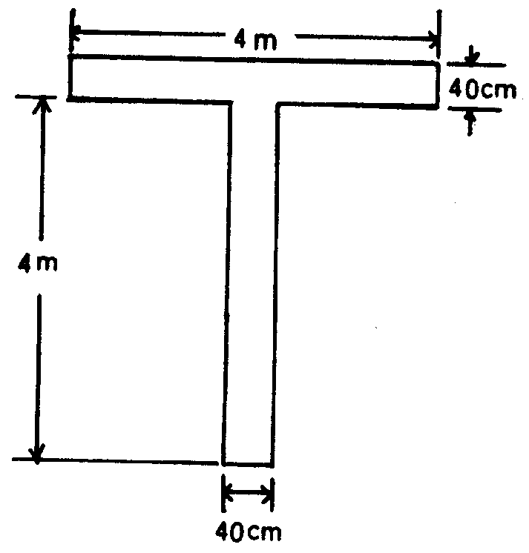
Figure 1
(3) A white disc 60 centimetres in diameter displayed alongside the cross arm of the T and in line with the shaft of the T, as illustrated in this paragraph, signifies that the direction of landing and take-off do not necessarily coincide.
Figure 2
(4) A white dumb-bell, as illustrated in this paragraph, signifies that movements of aeroplanes and gliders on the ground shall be confined to paved, metalled or similar hard surfaces.
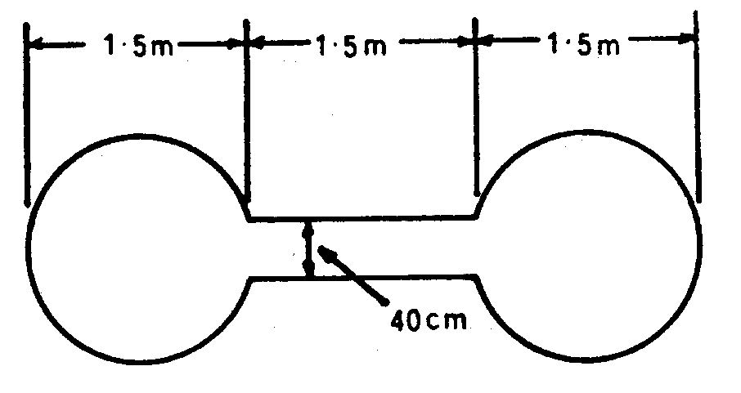
Figure 3
(5) A white dumb-bell as described in paragraph (4) but with a black stripe 60 centimetres wide across each disc at right angles to the shaft of the dumb-bell, as illustrated in this paragraph, signifies that aeroplanes and gliders taking off or landing shall do so on a runway but that movement on the ground is not confined to paved, metalled or similar hard surfaces.
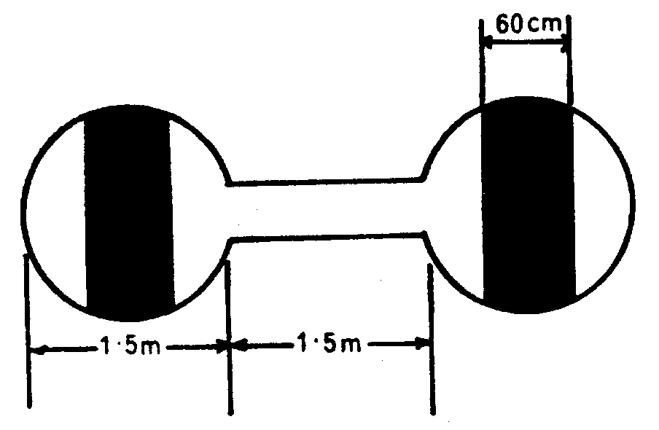
Figure 4
(6) A red and yellow striped arrow, as illustrated in this paragraph, the shaft of which is at least one metre wide placed along the whole or not less than a total of 11 metres of two adjacent sides of the signals area and pointing in a clockwise direction signifies that a right-hand circuit is in force.
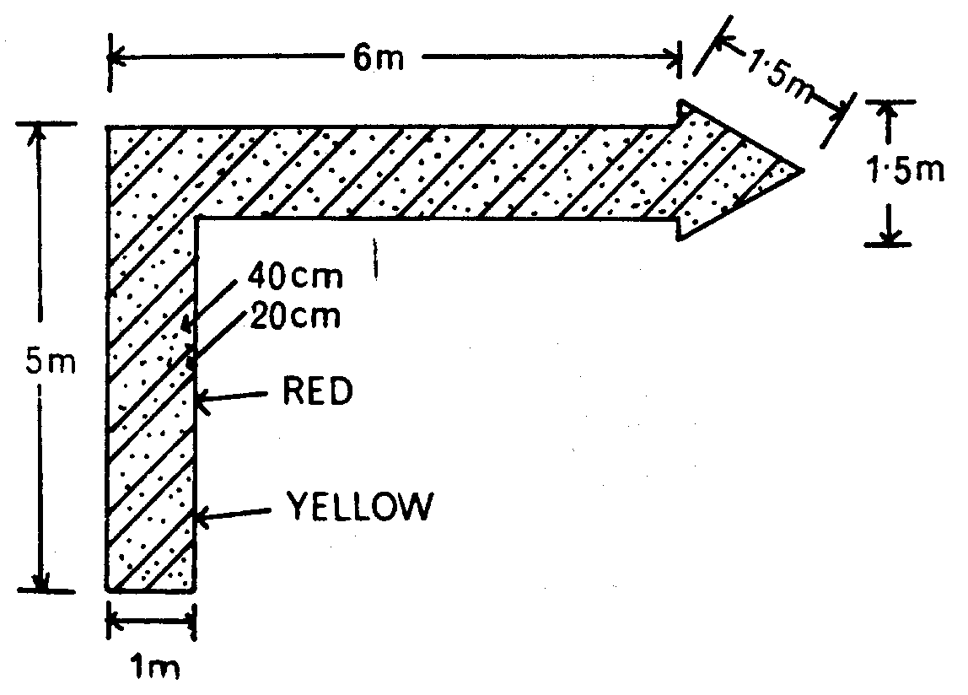
Figure 5
(7) A red panel 3 metres square with a yellow stripe along one diagonal at least 50 centimetres wide, as illustrated in this paragraph, signifies that the state of the manoeuvring area is poor and pilots must exercise special care when landing.
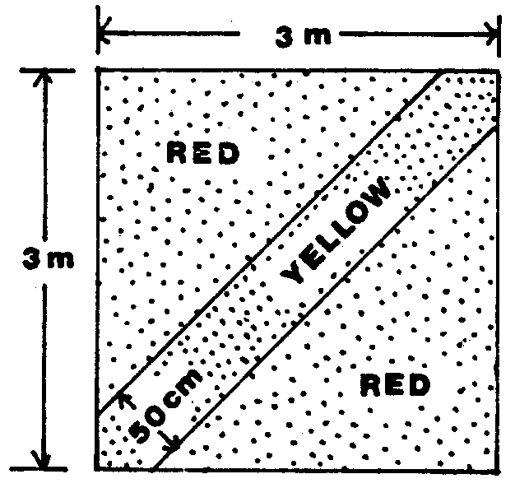
Figure 6
(8) A red panel 3 metres square with a yellow stripe, at least 50 centimetres wide, along each diagonal, as illustrated in this paragraph, signifies that the aerodrome is unsafe for the movement of aircraft and that landing on the aerodrome is prohibited.
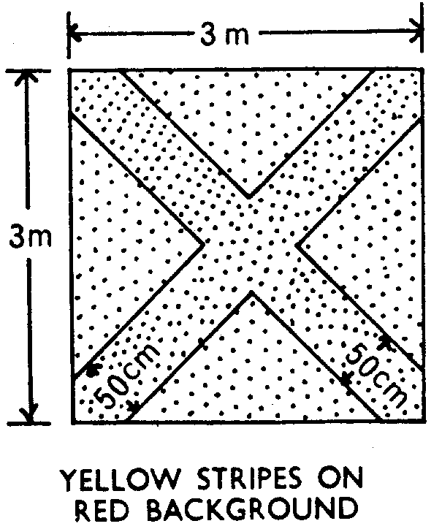
Figure 7
(9) A white letter H, as illustrated in this paragraph, signifies that helicopters shall take off and land only within the area designated by the marking specified in rule 41 (5).
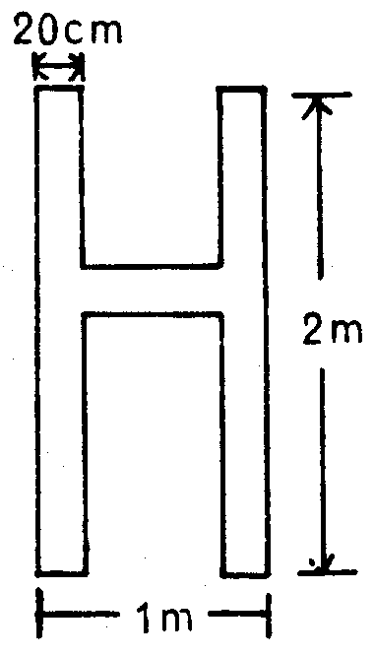
Figure 8
(10) A red letter L displayed on the dumb-bell specified in paragraphs (4) and (5), as illustrated in this paragraph, signifies that light aircraft are permitted to take off and land either on a runway or on the area designated by the marking specified in rule 41 (6).
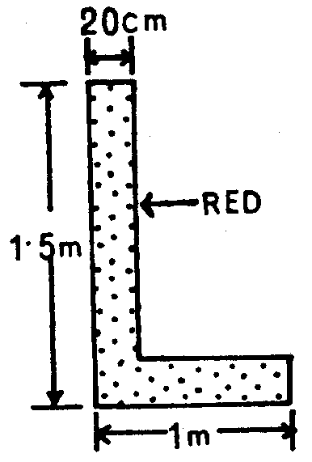
Figure 9
(11) A white double cross, as illustrated in this paragraph, signifies that glider flying is in progress.
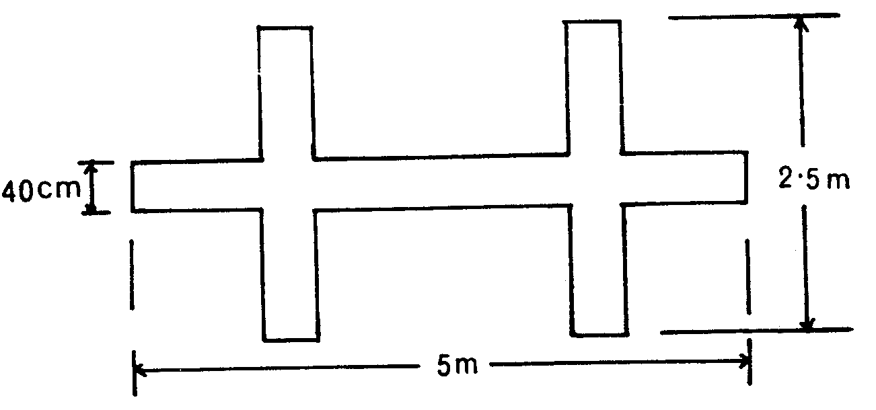
Figure 10
Markings for paved runways and taxiways
40. (1) Two or more white crosses, as illustrated in this paragraph, displayed on a runway or taxiway, with the arms of the crosses at an angle of 45° to the centre line of the runway, at intervals of not more than 300 metres signify that the section of the runway or taxiway marked by them is unfit for the movement of aircraft.
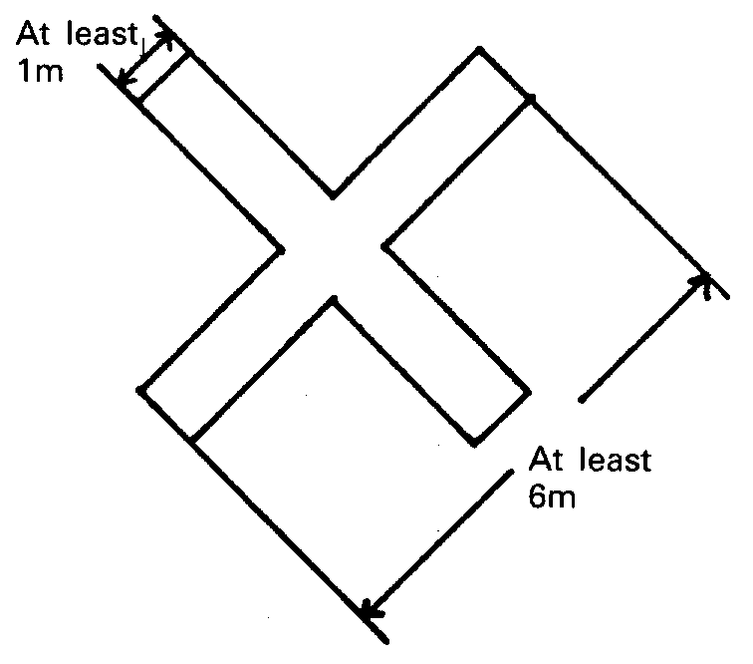
Figure 11
(2) A broken white line and a continuous line, as illustrated in this paragraph, signify a holding position beyond which no part of an aircraft or vehicle shall project in the direction of the runway without permission from an air traffic control unit.
Figure 12
(3) Orange and white markers, as illustrated in this paragraph, spaced not more than 15 metres apart, signify the boundary of that part of a paved runway, taxiway or apron which is unfit for the movement of aircraft.
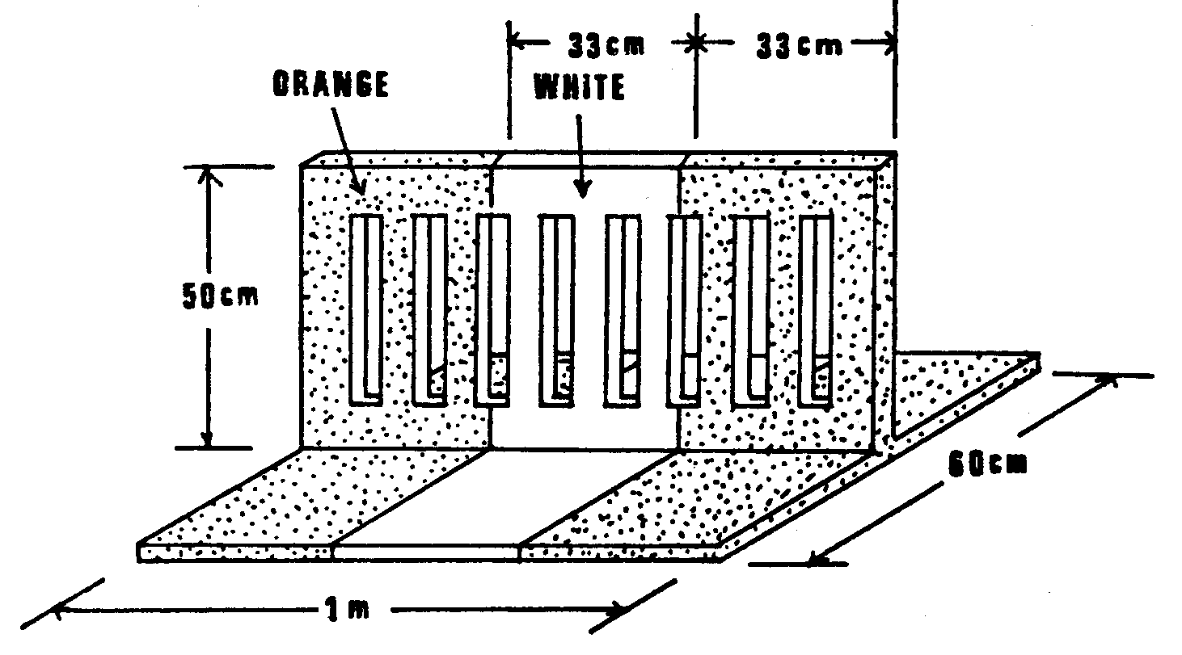
Figure 13
Markings on unpaved manoeuvring areas
41. (1) Markers with orange and white stripes of an equal width of not less than 50 centimetres, with an orange stripe at each end, as illustrated in this paragraph, alternating with flags not less than 60 centimetres square showing equal orange and white triangular areas, indicate the boundary of an area unfit for the movement of aircraft and one or more white crosses as specified in rule 40 (1) indicate the said area. The distance between any two successive orange and white flags shall not exceed 90 metres.
Figure 14
(2) Striped markers, as specified in paragraph (1), spaced not more than 45 metres apart, indicate the boundary of an aerodrome.
(3) On structures, markers with orange and white vertical stripes, of an equal width of not less than 50 centimetres, with an orange stripe at each end, as illustrated in this paragraph, spaced not more than 45 metres apart, indicate the boundary of an aerodrome. The pattern of the marker shall be visible from inside and outside the aerodrome and the marker shall be affixed not more than 15 centimetres from the top of the structure.
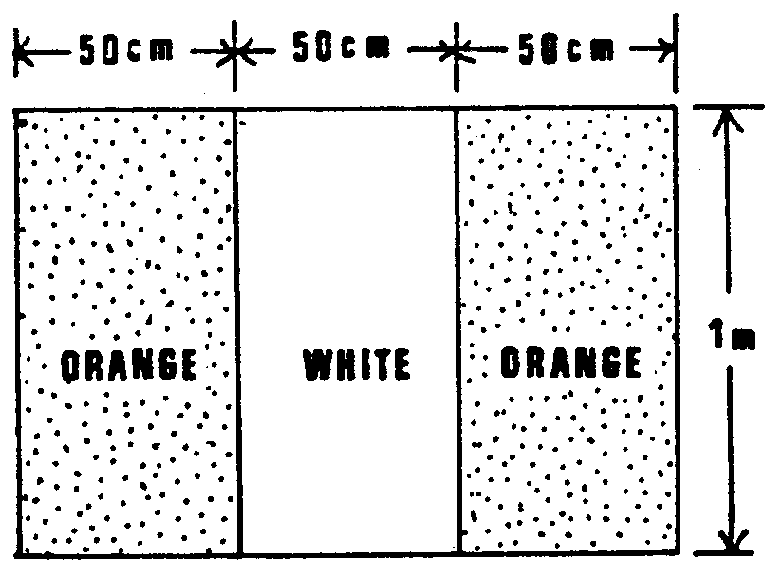
Figure 15
(4) White flat rectangular markers 3 metres long and one metre wide at intervals not exceeding 90 metres, flush with the surface of the unpaved runway or stopway, as the case may be, indicate the boundary of an unpaved runway or of a stopway.
(5) A white letter H, as illustrated in this paragraph, indicates an area which shall be used only for the taking off and landing of helicopters.
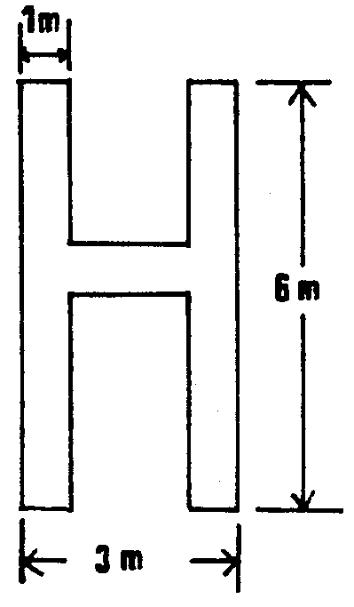
Figure 16
(6) A white letter L as illustrated in this paragraph, indicates a part of the manoeuvring area which shall be used only for the taking off and landing of light aircraft.
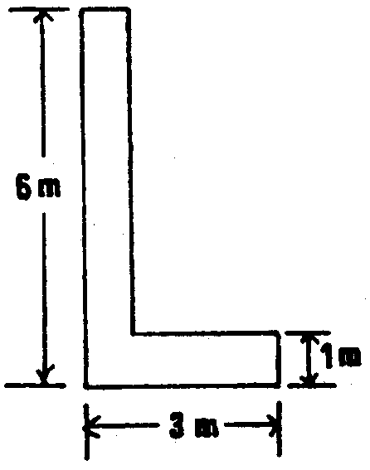
Figure 17
(7) A yellow cross with two arms 6 metres long by 1 metre wide at right angles, indicates that tow ropes and similar articles towed by aircraft shall only be dropped in the area in which the cross is placed.
(8) A white double cross as illustrated in this paragraph, indicates an area which shall be used only for the taking off and landing of gliders.
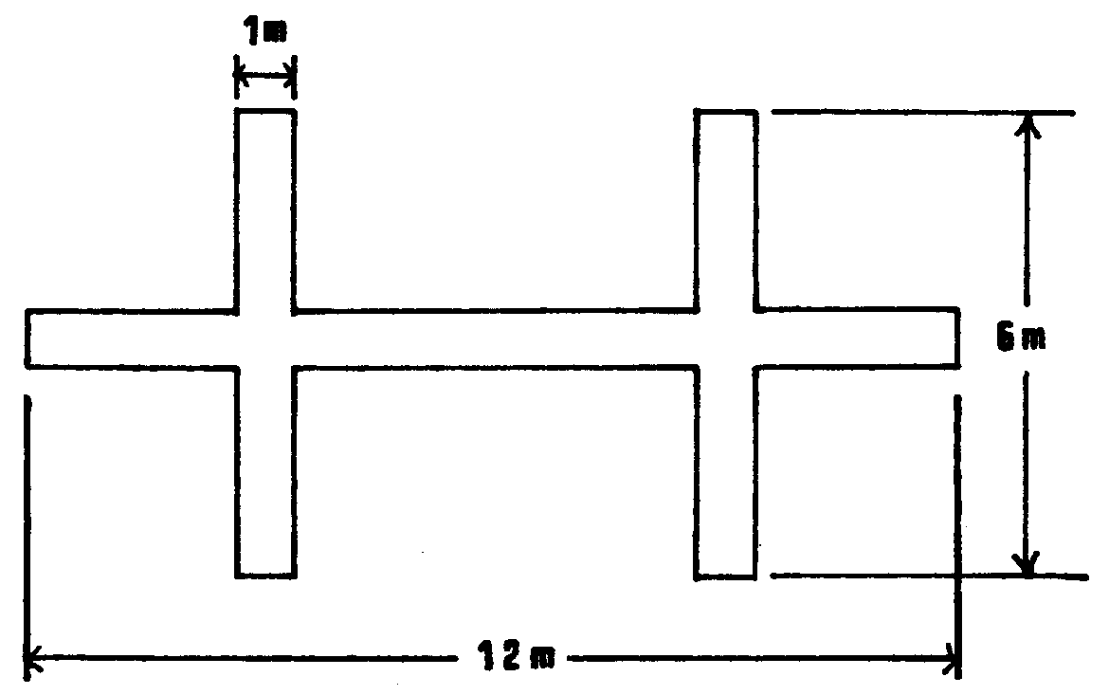
Figure 18
(9) A white landing T as specified in rule 30 (2) placed at the left hand side of the runway when viewed from the direction of landing indicates the runway to be used, and at an aerodrome with no runway it indicates the direction for take-off and landing.
Signals visible from the ground
42. (1) A black ball 60 centimetres in diameter suspended from a mast signifies that the directions of take- off and landing are not necessarily the same.
(2) A chequered flag or board, 1.2 metres by 90 centimetres containing 12 equal squares, 4 horizontally and 3 vertically, coloured red and yellow alternatively, signifies that aerodrome traffic on the manoeuvring area is subject to control by means of the lights and pyrotechnic signals referred to in rule 43.
(3) Two red balls 60 centimetres in diameter, disposed vertically one above the other, 60 centimetres apart and suspended from a mast, signify that glider flying is in progress at the aerodrome.
(4) Black Arabic numerals in two-figure groups and, where parallel runways are provided the letter or letters L (Left), LC (Left Centre), C (Centre), RC (Right Centre) and R (Right), placed against a yellow background, indicate the direction for take-off or the runway in use.
(5) A black letter C against a yellow background, as illustrated in this paragraph, indicates the position at which a pilot can report to the air traffic control unit or to the person in charge of the aerodrome.
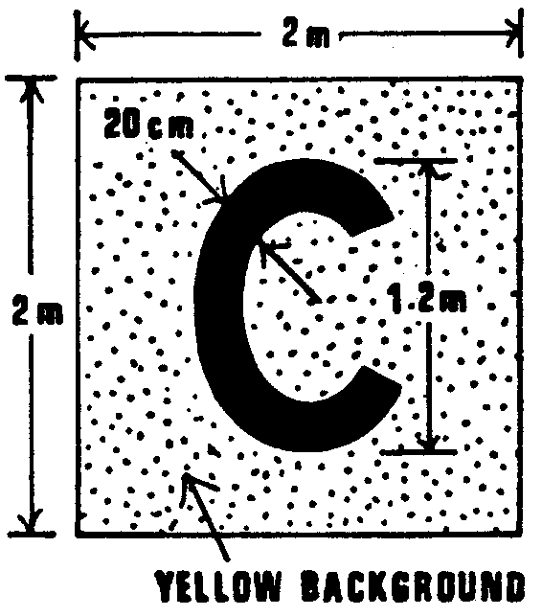
Figure 19
(6) A rectangular green flag of not less than 60 centimetres square flown from a mast indicates that a right-hand circuit is in force.
Lights and pyrotechnic signals for control of aerodrome traffic
43. Each signal described in the first column of Table A, when directed from an aerodrome to an aircraft or to a vehicle, or from an aircraft, shall have the meanings respectively appearing in the second, third and fourth columns of that Table opposite the description of the signal.
TABLE A
44. Signals for the guidance of aircraft manoeuvring on or off the ground shall, in Macao, have the meaning as shown in Table B. By day any such signals shall be given by hand or by circular bats and by night by torches or illuminated wands.
Characteristic and colour of light beam or pyrotechnic | From an aerodrome |  | From an aircraft in flight to an aerodrome
Characteristic and colour of light beam or pyrotechnic | to an aircraft in flight | to an aircraft or vehicle on the aerodrome | From an aircraft in flight to an aerodrome
(a) Continuous red light | Give way to other aircraft and continue circling | Stop | -----
(b) Red pyrotechnic light, or Red flare | Do not land; wait for permission | ----- | Immediate assistance is required
(c) Red flashes | Do not land; aerodrome not available for landing | Move clear of landing area | -----
(d) Green flashes | Return to aerodrome; wait for permission to approach and land | To an aircraft: You may move on the manoeuvring area and apron;  To a vehicle: You may move on the manoeuvring area | -----
(e) Continuous green light | You may land | You may take off (not applicable to a vehicle) | -----
(f) Continuous green light or green flashes, or green pyrotechnic light | ----- | ----- | By night: May I land? By day May I land in direction different from that indicated by landing T?
(g) White flashes | Land at this aerodrome after receiving continuous green light, and then, after receiving green flashes, proceed to the apron | Return to starting point on the aerodrome | I am compelled to land immediately
(h) White pyrotechnic lights, switching on and off the navigation lights, or switching on and off the landing lights | ----- | ----- | I am compelled to land immediately
TABLE B - MEANING OF MARSHALLING SIGNALS (Rule 44)
1. To proceed under further guidance by signalman.  Signalman directs pilot if traffic conditions on aerodrome require this action. | 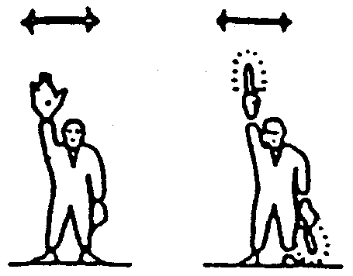
2. This bay.  Arms above head in vertical position with palms facing inward. | 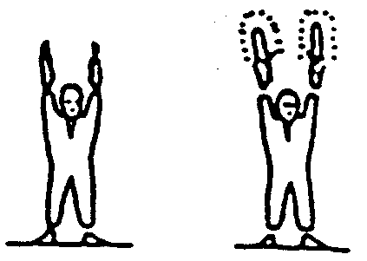
3. Proceed to next signalman.  Right or left arm down, other arm moved across the body and extended to indicate direction of next signalman. | 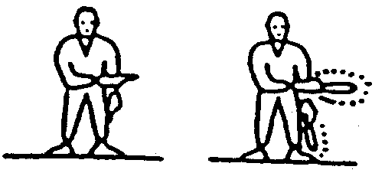
4. Move ahead.  Arms little aside, palms facing backward and repeatedly moved upward-backward from shoulder height. | 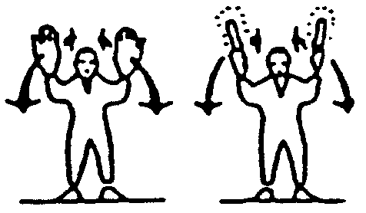
5. Turn.  a) Turn to your left: right arm downward, left arm repeatedly moved upward-backward. Speed of arm movement indicating rate of turn.  b) Turn to your right: left arm downward, right arm repeatedly moved upward-backward. Speed of arm movement indicating rate of turn. | 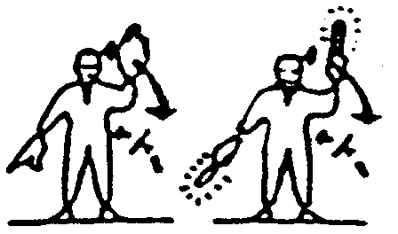  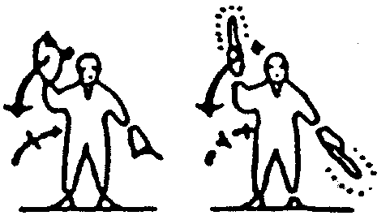
6. Stop.  Arms repeatedly crossed above head (the rapidity of the arm movement should be related to the urgency of the stop i.e. the faster the movement the quicker the stop). | 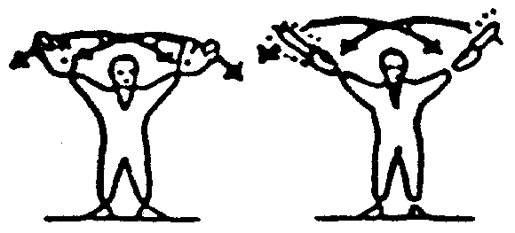
7. Brakes.  a) Engage brakes: raise arm and bend, with fingers extended, horizontally in front of body, then clench fist.  b) Release brakes: raise arm, with fist clenched, horizontally in front of body, then extend fingers. | 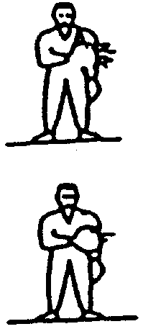
8. Chokes.  a) Chokes inserted: arms down, palms facing inwards, move arms from extended position inwards.  b) Chokes removed: arms down, palms facing outwards, move arms outwards. | 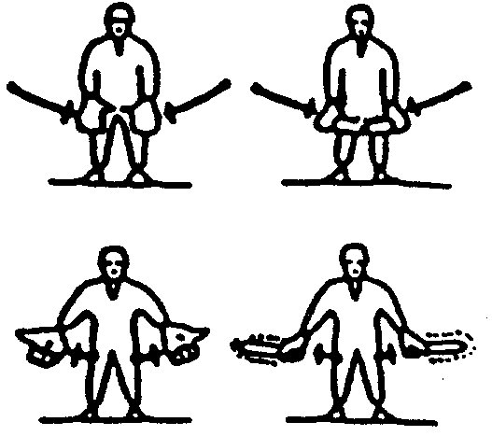
9. Start engine(s).  Left hand overhead with appropriate number of fingers extended, to indicate the number of the engine to be started, and circular motion of right hand at head level. | 
10 Cut engine(s).  Either arm and hand level with shoulder, hand across throat, palm downward. The hand is moved sideways with the arm remaining bent. | 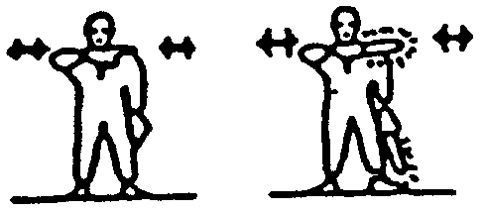
11. Slow down.  Arms down with palms toward ground then moved up and down several times. | 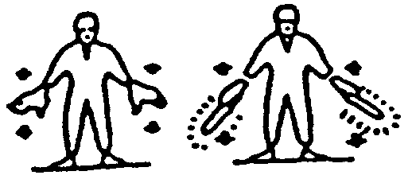
12. Slow down engine(s) on indicated side.  Arms down with palms toward ground. | 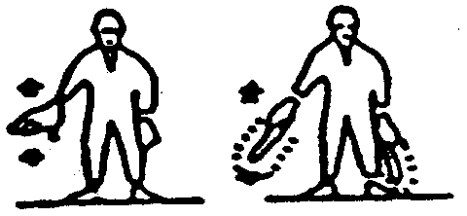
13. Move back.  Arms by sides, palms facing forward, swept forward and upward repeatedly to shoulder height. | 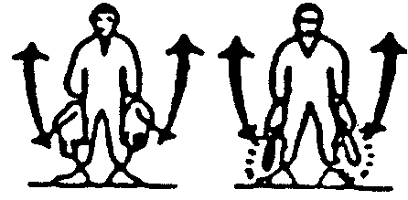
14. Turns wile backing.  a) For tail to starboard: point left arm down, and right arm brought from overhead, vertical position to horizontal forward position, repeating right arm movement.  b) For tail to part: point right arm down, and left arm brought from overhead, vertical position to horizontal forward position, repeating left arm movement. | 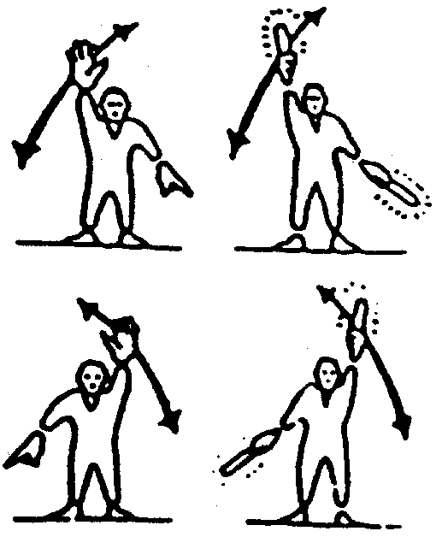
15. All clear.  Right arm rose at elbow with thumb erect. | 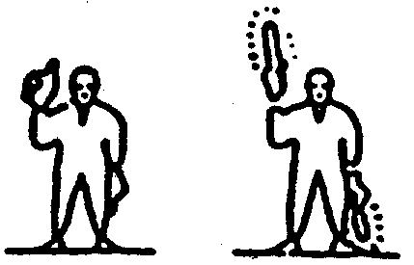
16. Hover.
Arms extended horizontally sideways.
17. Move upwards.  Arms extended horizontally to the side backoning upwards, with palms turned up. Speed of movement indicates rate of ascent. | 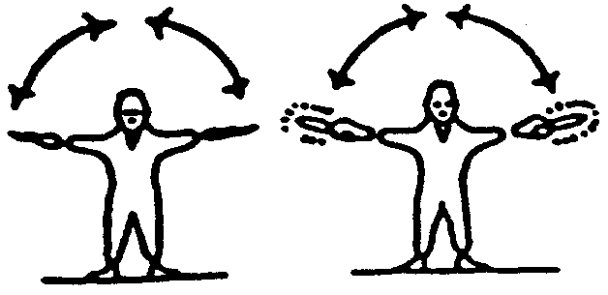
18. Move downwards.
Arms extended horizontally to the side beckoning downwards, with palm turned down. Speed of movement indicates rate of descent.
19. Move horizontally  Appropriate arm extended horizontally sideways in direction of movement and other arm moved in front of body in same direction, in a repeating movement. | 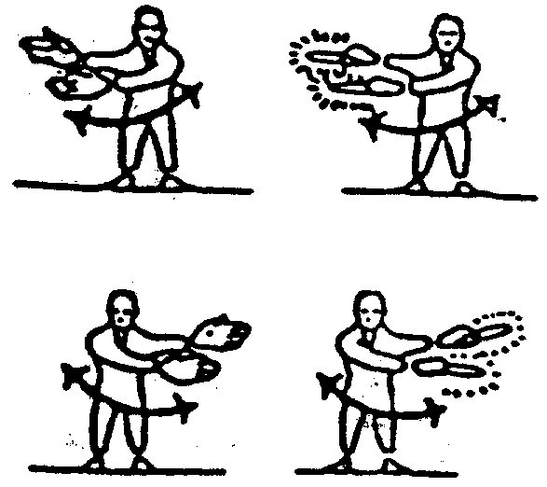
20. Land  Arms crossed and extended downwards in front of the body. | 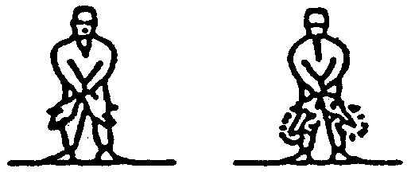
Marshalling signals (from a pilot of an aircraft to a marshaller)
45. The following signals made by a pilot in an aircraft to a marshaller on the ground shall respectively have the following meanings:

Description of signal | Meaning of signal
(a) Raise arm and hand with fingers extended horizontally in front of, face, then clench fist. | Brakes engaged.
(b) Raise arm with fist clenched horizontally in front of face, then extend fingers. | Brakes released.
(c) Arms extended palms facing outwards, move hands inwards to cross in front of face. | Insert chocks.
(d) Hands crossed in front of face, palms, facing outwards, move arms outwards. | Remove chocks.
(e) Raise the number of fingers on one hand indicating the number of the engine to be started. For this purpose the aircraft engines shall be numbered in relation to the marshaller facing the aircraft, from his right to his left, for example, No. 1 engine shall be the port outer engine, No. 2 shall be the port inner engine, No. 3 engine shall be the starboard inner engine and No. 4 engine shall be the starboard outer engine. | Ready to start engine.
Distress, urgency and safety signals
46. (1) The following signals, given either together or separately before the sending of a message, signify that an aircraft is threatened by grave and imminent danger and requests immediate assistance:
(a) by radiotelephony - the spoken word "Mayday";
(b) by visual signalling:
(i) the signal SOS ( . . . - - - . . . );
(ii) a succession of pyrotechnic lights fired at short intervals each showing a single red light;
(iii) a parachute flare showing a red light;
(c) by sound signalling other than radiotelephony:
(i) the signal SOS ( . . . - - - . . . );
(ii) a continuous sounding with any sound apparatus.
(2) The following signals, given either together or separately, before the sending of a message, signify that the commander of the aircraft wishes to give notice of difficulties but that he does not require immediate assistance:
(a) a succession of white pyrotechnic lights;
(b) the repeated switching on and off of the aircraft landing lights;
(c) the repeated switching on and off of its navigation lights, in such a manner as to be clearly distinguishable from the flashing navigation lights described in rule 11.
(3) The following signals, given either together or separately, indicate that the commander of the aircraft has an urgent message to transmit concerning the safety of the aircraft or of any person or property:
(a) by radio telephony - the spoken word "PAN";
(b) by visual signalling:
(i) the signal XXX ( - . . - - . . - - . . - );
(ii) a succession of green pyrotechnic lights;
(iii) a succession of green flashes;
(c) by sound signalling other than radiotelephony - the signal XXX ( - . . - - . . - - . . - ).
Warning signals to aircraft in flight
47. In Macao, the following signals shall respectively have the following meanings:
(a) (i) by day - a series of projectiles discharged at intervals of 10 seconds, each showing on bursting black or white smoke; or
(ii) by night - a series of projectiles discharged at intervals of 10 seconds, each showing on bursting white lights or stars, or an intermittent white luminous beam directed at the aircraft - indicates that the aircraft to which the signal is directed is in the vicinity of such an area as is referred to in paragraph 63 (1) of the Regulation and is required to change its course;
(b) by day or by night, a series of projectiles discharged at intervals of 10 seconds, each showing on bursting green lights or stars, indicates that the aircraft is required to land at the nearest aerodrome in accordance with paragraph 63 of the Regulation.

